

**BARISHAL LOUNCH**

**TRANSPORT-BANGLADSH**



Table of Contents

[1 Introduction: 3](New%20Microsoft%20Word%20Document%20(2).docx)

[1.1 History of Barishal launch: 3](New%20Microsoft%20Word%20Document%20(2).docx)

[1.2 Mission and vision: 3](New%20Microsoft%20Word%20Document%20(2).docx)

[1.3 Barishal launch branding identity: 4](New%20Microsoft%20Word%20Document%20(2).docx)

[2. Building a Strong Brand for “Barishal Launch Transport” 4](New%20Microsoft%20Word%20Document.docx)

[2.1 Understand the Target Audience: 4](New%20Microsoft%20Word%20Document%20(3).docx)

[2.2 Brand Promise 5](New%20Microsoft%20Word%20Document.docx)

[2.3 Emotional Connection: 5](New%20Microsoft%20Word%20Document%20(4).docx)

[2.4 Visual Identity: 5](New%20Microsoft%20Word%20Document%20(4).docx)

[2.5 Customer Engagement 5](New%20Microsoft%20Excel%20Worksheet%20(2).xlsx)

[2.6 Consistent Customer Experience: 6](New%20Microsoft%20Excel%20Worksheet%20(2).xlsx)

[2.7 Promotion & Launch Strategy: 6](New%20Microsoft%20Word%20Document%20(4).docx)

[3. Product & Services Positioning 6](New%20Microsoft%20Word%20Document%20(2).docx)

[3.1 Product: 6](New%20Microsoft%20Word%20Document.docx)

[3.1.1 Modern Fleet & Safety: 6](New%20Microsoft%20Word%20Document%20(3).docx)

[3.1.2 Luxurious and Comfortable: 7](New%20Microsoft%20PowerPoint%20Presentation.pptx)

[3.2 Services: 7](New%20Microsoft%20Word%20Document%20(3).docx)

[4. Ship manufacturing company challenges 8](New%20Microsoft%20Word%20Document%20(3).docx)

[5. Future Goals 9](New%20Microsoft%20Word%20Document%20(3).docx)

[5.1 Short-Term Goals 9](New%20Microsoft%20Word%20Document%20(3).docx)

[5.2 Long-Term Goals: 10](New%20Microsoft%20Word%20Document%20(4).docx)

[6. Conclusion 10](New%20Microsoft%20Word%20Document%20(2).docx)

# 1 Introduction:

## History of Barishal launch:

The Barisal river port has a recorded existence since the Mughal Empire. It was then called “Gird-e-Bandar”, a river station which was known for the trade of salt, spices, and woods. It was turned into Barisal Bandar (port) during the British rule after the town committee was established in 1869 and achieved municipal status in 1876.

EPIWTA was named as Bangladesh Inland Water Transport Authority (BIWTA), which currently takes care of all related development, maintenance, and operations of inland water transport and of inland waterways in Bangladesh.

## 1.2 Mission and vision:

The mission and vision of ships have evolved over time. Initially used for transportation and trade, ships now focus on promoting global connectivity, supporting international trade, and facilitating travel and tourism. Their vision includes enhancing safety, efficiency, and sustainability to meet the demands of a changing world while prioritizing customer service and environmental responsibility.

Ship companies focus on providing a safe, comfortable, and enjoyable experience for passengers and cargo owners. Customer service on ships includes ensuring a pleasant journey, addressing passenger needs, and maintaining high standards of hospitality to enhance the overall experience onboard.

## 1.3 Barishal launch branding identity:

**1. Barishal Launches**: Navigating the Waterways Barishal, a city in southern Bangladesh, is known for its picturesque rivers and waterways. Launches (large passenger boats) play a crucial role in connecting Barishal with other cities, including Dhaka. Here’s what you need to know:

**2. Dhaka-Barishal Route**: The Dhaka-Barishal route is one of the most popular waterway connections in the country. Launches ply this route, providing both transportation and scenic views along the way.

**3. Luxurious Launches**: Among the launches operating on this route, some are quite luxurious and comfortable. For example, the Sundarban 11 launch is known for its spacious interiors, good staff behavior, and cleanliness1. If you’re looking for a pleasant journey, this might be a great choice.

**4. Ticket Prices and Contact Numbers**: If you’re planning a trip, it’s essential to know the ticket prices and contact details. You can find up-to-date information on launch schedules, ticket prices, and contact numbers online2. Keep an eye out for launches like Greenline Water Bus, Adventure 5, Parabat, Surovi, Sundarban, Manami, and Kirtonkhola.

**5. Exploring the Waterways**: Imagine cruising along the rivers, passing lush green landscapes, and feeling the gentle sway of the boat. Some travelers even document their experiences on YouTube, sharing their journeys from Dhaka to Barishal and vice versa.

# 2. Building a Strong Brand for “Barishal Launch Transport”

## 2.1 Understand the Target Audience:

* + **Daily Commuters**: People who rely on local transport to get to work or school.
  + **Students**: Young passengers who need affordable and reliable services.
  + **Tourists & Visitors**: Travelers seeking convenient routes to explore Barishal.
  + **Locals with Accessibility Needs**: Elderly or disabled individuals who require reliable and safe transportation options.

**Customer Insight**: They need affordability, safety, timeliness, and a comfortable

Experience.

2.2 Brand Promise:

* + **Safety**: Provide secure transportation for all, including women and the elderly.
  + **Punctuality**: Commit to a reliable schedule and timely service.
  + **Affordability**: Offer reasonable pricing for daily commuters and students.
  + **Community-Focused**: Be a local transport service that listens to and evolves with the needs of Barishal’s residents.
  + **Message Example**: “Barishal Launch Transport – Safe, Timely, and Affordable for Everyone.”

## 2.3 Emotional Connection:

* + **Storytelling**: Highlight the importance of community connection, with stories of people relying on Barishal Launch Transport to stay connected with their work, family, and opportunities.
  + **Local Culture**: Integrate Barishal’s rich cultural and geographical identity into the branding. This could be reflected in your logo, tagline, or campaigns that emphasize how the service enhances local life.
  + **Campaign Idea**: “Connecting Barishal: Every Journey Tells a Story” — where local residents share their experiences using the transport service.

## 2.4 Visual Identity:

* + **Logo**: Create a design that reflects local culture—perhaps using imagery of the rivers and boats that define Barishal’s geography.
  + **Colors**: Use colors that represent reliability (like blue) and energy (like green or orange) to attract attention and instill confidence.
  + **Typography**: Choose modern and readable fonts that convey professionalism and trust.

2.5 Customer Engagement:

* + **Feedback Loops**: Implement systems where passengers can give feedback on their ride experience, routes, or service improvements.
  + **Social Media Engagement**: Use platforms like Facebook and Instagram to share updates, and promotions, and encourage passengers to share their experiences.
  + **Community Involvement**: Partner with local events, schools, or businesses to create a stronger community bond. Sponsoring local initiatives or transportation discounts during events can create goodwill.

## 2.6 Consistent Customer Experience:

* + Ensure that from the moment a customer boards your transport, they experience the core values of your brand—safety, punctuality, and affordability.
  + Train drivers and staff to be customer-friendly and maintain high service standards.

## 2.7 Promotion & Launch Strategy:

* + **Introductory Offers**: Provide free or discounted rides for the first few weeks to encourage people to try the service.
  + **Local Media & Partnerships**: Collaborate with local radio, newspapers, and influencers to spread the word. Consider launching with an event or gathering that highlights the new service and its community impact.
  + **Digital Presence**: Create a simple, user-friendly website and an app that provides route information, fare details, and service updates.

# 3. Product & Services Positioning

## 3.1 Product:

### 3.1.1 Modern Fleet & Safety:

The Modern launches in Bangladesh focus on safety and innovation, featuring GPS, radar, and advanced navigation systems. These vessels are equipped with life-saving measures like lifeboats, life vests, and well-marked safety instructions. With spacious, well-maintained decks and comfortable interiors, the fleet ensures both passenger comfort and security. The emphasis on modern technology enhances navigation through Bangladesh’s waterways, ensuring safe and reliable journeys.

### 3.1.2 Luxurious and Comfortable:

The most luxurious launches in Bangladesh, like the Sundarban-10 and Kirtonkhola-10, offer high-end interiors with features such as VIP duplex business class cabins, food courts, and even coronary care units (CCU). Sundarban-10, a 300-foot, three-story vessel, is equipped with modern amenities like a lift, radar, and GPS. It can accommodate around 1,300 passengers, making the nine-hour journey from Dhaka to Barishal both comfortable and sophisticated

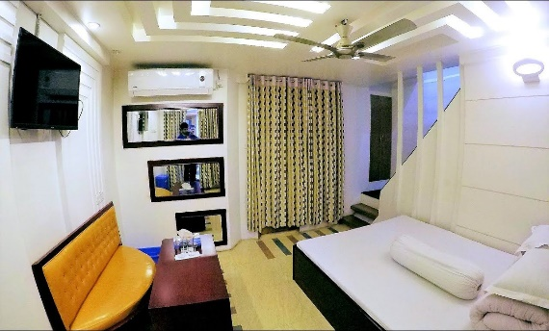 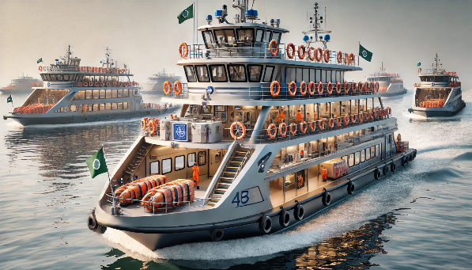

## 3.2 Services:

* **Punctuality & Convenience:** Bangladesh launches offer punctual service and convenience, ensuring timely departures and arrivals. This enhances passenger satisfaction, especially for long-distance routes like Dhaka-Barishal. With multiple modern amenities, these vessels provide a smooth and comfortable travel experience, perfect for both leisure and business travelers.
* **Onboard Dining:** Offer quality food options (local and international), which can be an attractive service for long trips.
* **Wi-Fi & Entertainment:** Provide Wi-Fi services and entertainment systems onboard to keep passengers engaged.
* **Easy Booking & Customer Support:** Develop an easy-to-use online booking platform and responsive customer service for ticket bookings and inquiries.
* **Cargo Services:** Position the launch as a reliable option for carrying goods and cargo between Barishal and Dhaka.

 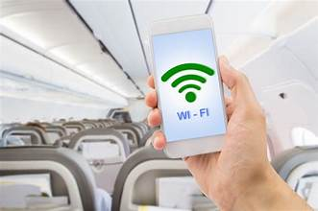 

# 4. Ship manufacturing company challenges

**1. Market Differentiation**: differentiate the lonch or ship from the competitor in the terms of service ,look make it more appealing from customer point of view , more efficient and update engine system than the competitor.

**2. Target Audience Identification**: Understanding the need and want of target consumer. Just try to understand the expectations of customers what kind of service they needed .In most of cases they need a good quality food with a good environment for their existing time being.

**3. Consistency**: Maintaining a consistent brand message across various platforms and experiences can be helpful.

**4. Reputation Management**: reputation is a big issue for a ship company so they should serve properly to the customer, as well as handle negative feedback with great concern, take complain serious and solve customer problem.

**5. Visual Identity**: Designing a strong visual identity that resonates with customers while maintain ship environment.

**6. Partnerships and Collaborations**: Collaborating with other brands like surovi , prince aloud ,paravot ,these strategy can enhance their image. Also they can hire famous influencer of Barishal as well as actor to branding their new launch.

**7. Customer Experience**: giving customer utmost satisfaction. it will give them repeat customer base as well as good reputation.

**8. Sustainability**: Increasingly, customers expect brands to demonstrate environmental responsibility, which will create a good image for the ship manufacturing company.

# 5. Future Goals

## 5.1 Short-Term Goals

**1. Infrastructure Upgrades**: Modernize launch terminals with improved amenities such as waiting rooms, sanitation facilities, and security systems. Strengthen safety measures, including life-saving equipment and trained personnel onboard.

**2. Operational Efficiency**: Increase the frequency of services, especially during peak hours, to reduce waiting times. Introduce more fuel-efficient vessels to cut down on operational costs and improve service reliability.

**3. Digitalization of Services**: Implement online ticketing and reservation systems, allowing passengers to book in advance and reducing the need for physical ticket counters. Launch mobile apps for real-time tracking of launches, enabling passengers to better plan their journeys.

**4. Enhanced Passenger Experience**: Improve onboard amenities such as seating, food options, and cleanliness. Offer premium services like air-conditioned cabins or fast-launch options to attract higher-income passengers.

**5. Marketing and Branding**: Launch marketing campaigns to promote Barishal as a travel destination and highlight the convenience of launch transportation. Collaborate with local tourism boards to create package deals for travelers.

## 5.2 Long-Term Goals:

**1. Expansion of Service Routes**: Expand the network to include underserved rural areas, promoting regional development and improving access to essential services. Develop express services between major ports like Barisal, Dhaka, and Chandpur for faster travel.

**2. Fleet Modernization and Sustainability**: Replace older vessels with newer, more fuel-efficient or hybrid/electric launches to reduce carbon emissions and promote sustainability. Invest in larger vessels that can accommodate more passengers and cargo, addressing future demand.

**3. Multimodal Transport Integration**: Integrate the launch transport system with other modes of transport (e.g., buses and trains) through coordinated schedules and common ticketing platforms to create a seamless travel experience. Establish river ports as multimodal hubs to connect river, road, and rail transport.

**4. Tourism Development**: Collaborate with the tourism sector to develop special river cruise services, showcasing the natural beauty of the region. Promote Barisal as a key destination for eco-tourism, driving traffic to the launch services.

**5. Public-Private Partnerships (PPP) and International Expansion**: Foster public-private partnerships to bring in investment for infrastructure upgrades and fleet expansion. Explore international river routes connecting Barisal with neighboring countries like India, increasing trade and passenger flow across borders.

**6. Technological Innovation**: Invest in advanced navigation and communication technologies to improve operational efficiency and safety. Explore the use of autonomous vessels in the future to reduce operational costs and enhance service reliability.

# 6. Conclusion

In conclusion, the Barisal Launch Transport system serves as a critical lifeline for connecting the Barisal region with other parts of Bangladesh. With its extensive river network, it plays a vital role in passenger and cargo transportation. However, there is immense potential for improvement through short-term goals such as infrastructure upgrades, safety enhancements, digitalization, and service efficiency, which will immediately improve user experience and operational reliability.

In the long-term, expanding routes, modernizing the fleet, integrating with other transport modes, and focusing on sustainability will help the system meet future demand and environmental goals. Public-private partnerships and tourism development will further boost its economic viability. Overall, with strategic investment and modernization, Barisal Launch Transport can be transformed into a more efficient, reliable, and sustainable transport network, enhancing regional connectivity and contributing to economic growth.